ALFA-LCP: Advanced Laboratory and Field Arrays – Lab Collaboration Project

# Task 11 Nonlinear Ocean Waves and PTO Control Strategy

## Task 11.2 Laboratory Experiments for Highly Nonlinear WEC-Wave Conditions

## Task 11.3 Improve Nonlinear WEC-Wave Representation in WEC-Sim for High Energy Cases

## **Data Report for M11.2.1, M11.2.2 and M11.3.5**

|  |  |  |
| --- | --- | --- |
| **Bryson Robertson, PhD**  Co-Director, Pacific Marine Energy Center  Oregon State University | **Ted Brekken, PhD**  Professor, Electrical Engineering and Computer Science  Oregon State University | **Tuba Ozkan-Haller, PhD**  Professor, College of Engineering and College of Earth, Ocean and Atmospheric Sciences  Oregon State University |
| **Solomon Yim, PhD**  Professor, Civil and Construction Engineering  Pacific Marine Energy Center  Oregon State University | **Pedro Lomonaco, PhD**  Director, O.H. Hinsdale Wave Research Laboratory  Pacific Marine Energy Center  Oregon State University | **Bret Bosma, PhD**  Faculty Research Associate  O.H. Hinsdale Wave Research Laboratory  Oregon State University |
| **Jim Thompson, PhD**  Professor, Civil and Environmental Engineering  Applied Physics Laboratory  University of Washington | **Nasim Adami**  PhD Student, School of Civil and Construction Engineering  Oregon State University | **Ali Mohtat**  PhD Student, School of Civil and Construction Engineering  Oregon State University |

April 2020

# Background

This document describes the experiments carried out in December 2019 and February-March 2020 in the Directional Wave Basin at the O.H. Hinsdale Wave Research Laboratory, Oregon State University.

Regular and irregular waves were generated in the absence and presence of a Wave Energy Converter, where different wave generation and control strategies were applied, emphasizing on nonlinear wave conditions and nonlinear PTO control. Direct comparisons of standard linear and 2nd-order wave generation with a newly developed fully nonlinear wave generation technique.

This document is part of a DOE deliverable report for the tasks due in Apr 2020. The tasks covered here are:

|  |  |  |
| --- | --- | --- |
| M11.2.1 | Data set involving nonlinear wave generation in the absence of a WEC. | Provide data report detailing test cases and available data |
| M11.2.2 | Data set involving WECs within the nonlinear wave field. | Provide data report detailing test cases and available data |
| M11.3.5 | Nonlinear wave time series software validated using lab data (without WECs) | Data-model comparisons with lab data | |

Details of each task are presented in the following sections.

# Task M11.2.1: Data set involving nonlinear wave generation in the absence of a WEC

Experiments presented in this section for undisturbed condition were conducted at the Directional Wave Basin (DWB) in O.H. Hinsdale Wave Research Laboratory (HWRL), Oregon State University, during the 2019-2020 academic year.

The Directional Wave Basin is 48.8 m long and 26.5 m wide, with 2.1 m high walls and a maximum still water depth of 1.5 m. It is constructed as a reinforced concrete reservoir, with a 15 cm wall and floor thickness. Two vehicle access ramps, 3 m and 2.5 m wide, allow equipment and materials to be transported conveniently into and out of the basin. A bridge crane with a capacity of 7.5 tons spans the length and width of the DWB to position the models and to facilitate instrumentation. Unistrut inserts are placed in rows at 1.22 m spacing to affix specimens, and instrumentation throughout the basin. The DWB wavemaker is a multidirectional piston-type with 30 independently-programmable servomotor-driven points. Each drive point has a maximum stroke of 2 m and a maximum velocity of 2 m/s. The wavemaker is capable of generating repeatable regular, irregular, tsunami, and user-defined waves, and is equipped with an active reflected wave cancellation system. It is also equipped with a removable steel beach with a 1:10 slope as passive wave absorber.

The general objective of the experiments of this Task was to produce a detailed dataset of free surface elevation time series of wave fields with different degree of nonlinearities, using selected wavemaker theories. This dataset can be considered a benchmark for future environmental analysis and system identification for the WEC systems. The experiments conducted to study solely the behavior of waves, in the absence of any model disturbance, are called undisturbed wave tests.

The undisturbed experiments were conducted in two phases, phase one in December 2019, and phase 2 in January thru March 2020. During phase one, a total of 16 resistance-based (wgX) and 4 ultra-sonic (uswgX) wave gauges were installed. During this phase, two water depths were considered, i.e. 1.0 m and 1.36 m. The coordinates and names of the deployed wave gauges are presented in Table 1 and the schematic drawing of the instrument layout is shown in Figure 1. As will be shown later, the same 6 m by 6 m frame used in phase 1, was used during the disturbed wave tests to deploy 8 cameras and track the motions of a specimen located at the center of the frame. Moreover, due to the design and operation constraints of the WEC, the space above the model was freed to give access to the overhead crane, which was used to deploy and retrieve the model as needed. The disturbed wave tests (in the presence of the WEC) were executed in February and March, 2020, alternating with the second phase of the undisturbed wave tests.

Table 1: Coordinates of the instruments for the undisturbed wave tests phase 1.

|  |  |  |  |
| --- | --- | --- | --- |
| Instruments deployed during the undisturbed wave tests phase 1 | | | |
| Name | x | y | z |
| wg1 | 4.609 | -0.039 | - |
| wg2 | 7.054 | -0.023 | - |
| wg3 | 9.483 | -0.031 | - |
| wg4 | 11.936 | -0.023 | - |
| wg5 | 14.279 | -1.404 | - |
| wg6 | 14.276 | -0.006 | - |
| wg7 | 14.288 | 1.581 | - |
| wg8 | 14.663 | -2.672 | - |
| wg9 | 14.714 | 2.801 | - |
| wg10 | 15.934 | -3.121 | - |
| wg11 | 15.954 | 3.126 | - |
| wg12 | 16.799 | -0.006 | - |
| wg13 | 18.230 | -0.027 | - |
| wg14 | 20.145 | -2.822 | - |
| wg15 | 20.124 | 2.620 | - |
| wg16 | 20.517 | -0.185 | - |
| uswg1 | 18.869 | -3.313 | 2.416 |
| uswg2 | 18.845 | 3.136 | 2.406 |
| uswg3 | 20.621 | -1.605 | 2.398 |
| uswg4 | 20.628 | 1.378 | 2.410 |

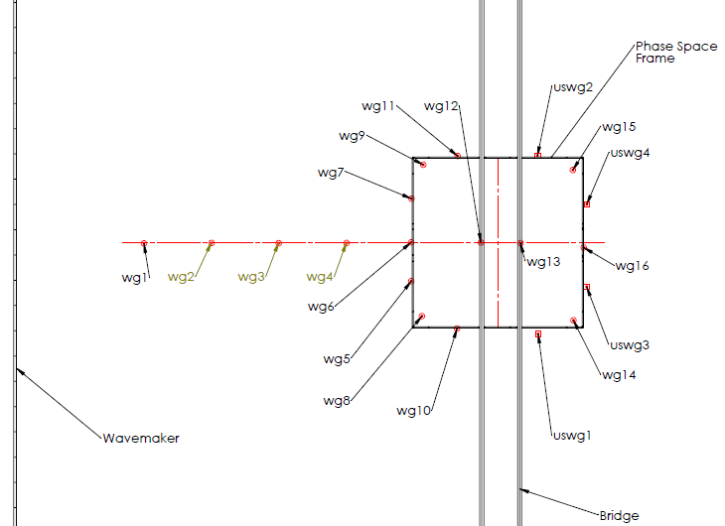

Figure 1: Wave gages layout in the basin during phase 1 of the undisturbed experiments.

During the second phase of the undisturbed tests, 4 columns were required to raise and support the PhaseSpace frame. In this way, motion tracking system was deployed at a higher elevation and remianed completely detached from any other structure to ensure vibrations are not affecting the measurements. Hence, the number of wave gauges were reduced, and naming were rearranged. During phase two, a total number of 14 resistance-based (scwgX and wgX) and 4 ultra-sonic wave gauges (uswgX) were installed, as shown in Figure 2. Coordinates and names of the deployed wave gauges are also included in Table 2.

Table 2. Coordinates of the instruments for the undisturbed wave tests phase 2.

|  |  |  |  |
| --- | --- | --- | --- |
| Instruments deployed during the undisturbed wave tests phase 2 | | | |
| Name | x | y | z |
| scwg1 | 4.601 | -0.023 | - |
| scwg2 | 7.051 | -0.022 | - |
| scwg3 | 9.477 | -0.029 | - |
| scwg4 | 11.914 | -0.010 | - |
| wg5 | 14.368 | -1.418 | - |
| wg6 | 14.380 | -0.037 | - |
| wg7 | 14.391 | 1.575 | - |
| wg8 | 14.657 | -2.637 | - |
| wg9 | 14.680 | 2.684 | - |
| wg10 | 15.830 | -3.012 | - |
| wg11 | 15.845 | 2.993 | - |
| wg12 | 20.032 | -2.704 | - |
| wg13 | 20.049 | 2.682 | - |
| wg14 | 20.383 | -0.057 | - |
| uswg1 | 18.898 | -3.179 | 2.359 |
| uswg2 | 18.797 | 3.176 | 2.356 |
| uswg3 | 20.536 | -1.464 | 2.387 |
| uswg4 | 20.541 | 1.510 | 2.371 |



Figure 2: Wave gages layout in the basin during phase 2 of the undisturbed experiments.

In Table 1 and Table 2, the x-axis is the cross-shore coordinate. Its origin (x = 0) is at a vertical plane that best fits the face of the wavemaker piston when it is neutrally positioned. The x-axis is measured in meters and positive onshore (away from the wavemaker). The z-axis is the vertical coordinate. The z-axis origin (z = 0) is at the average elevation of the basin floor. The z-axis is measured in meters and positive upwards. Finally, the y-axis is the alongshore coordinate (parallel to the wavemaker piston). The y-axis origin (y = 0) is at the alongshore centerline of the basin, i.e. halfway between two vertical planes that best fit the basin walls. The y-axis is measured in meters and positive to the left when facing onshore, so that the coordinate system is right-handed.

Given the operational condition of the majority of WECs is in intermediate to deep water regime, the nonlinearity parameter is chosen as the wave steepness $(ak)$, in which $a$ and $k$ represent, wave amplitude and wavenumber (*2π/L*), respectively. Given that WECs are ideally designed to operate in energetic and higher sea states, which are associated with larger nonlinearities, there is a strong need for an appropriate nonlinear wave generation and propagation method.

Regular and irregular waves with different degree of nonlinearities were generated using the linear and second order wave maker theories, in addition to a recently proposed nonlinear-Schrödinger-based wavemaker theory, and the resulting wave free surface elevation time series were measured and combined into a detailed dataset.

The total number of regular waves and irregular test cases are provided in Table 3 and Table 4, respectively. The tables show the applied wavemaker theory, the range of nonlinearity (steepness), and the total number of tests. The total number of undisturbed tests is 200.

Table 3: Regular wave tests for undisturbed condition.

|  |  |  |
| --- | --- | --- |
| Regular waves | | |
| Wavemaker theory | Range of steepness ($ak$) | Total number of cases |
| Linear wavemaker theory | 0.04-0.4 | 58 |
| 2nd-order wavemaker theory | 0.02-0.4 | 57 |
| NLS wavemaker theory | 0.02-0.4 | 71 |
| Total | | 186 |

Table 4: Irregular wave tests for undisturbed condition.

|  |  |  |
| --- | --- | --- |
| Irregular waves | | |
| Wavemaker theory | Range of steepness ($ak$) | Total number of cases |
| 2nd-order wavemaker theory | 0.02-0.18 | 7 |
| NLS wavemaker theory | 0.02-0.18 | 7 |
| Total | | 14 |

Characteristics of the experiments are presented in Figure 3 - Figure 6 for the selected wavemaker theories. The test cases were chosen in a way to cover a wide range of wave conditions, mostly in intermediate to deep-water. There are several number of overlapping wave conditions between the selected wavemaker theories that can be used for comparison between the implemented wavemaker theories. Each of the points shown in the figures represent an experiment with different wave conditions and water depth.

In these Figures, each of the wave conditions are represented by a single point and is defined in dimensionless form by the relative depth *h/L* in the x-axis, and the relative wave height *H/h* in the y-axis. In the graph, the validity of different wave theories are also included, as well as some classical limits, like the breaking limit by Miche (1944), deep water and shallow water limits, or two limits of the Ursell number, defined as *HL2/h3*.

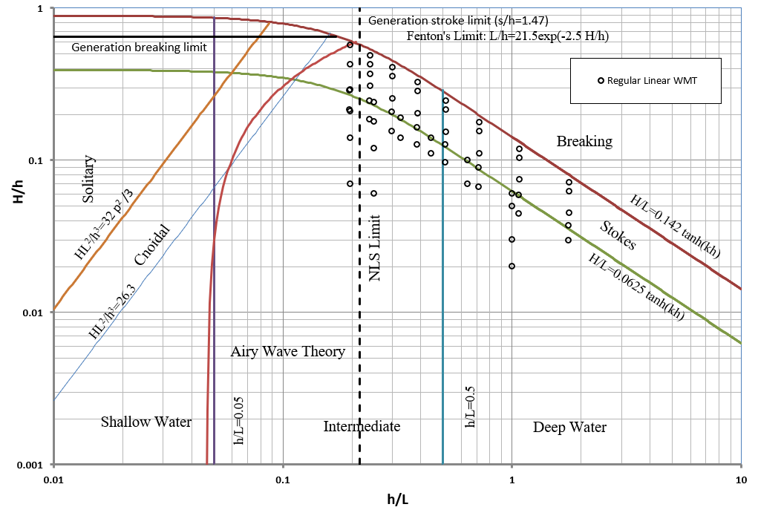

Figure 3: Regular waves generated using linear wavemaker theory (undisturbed condition).

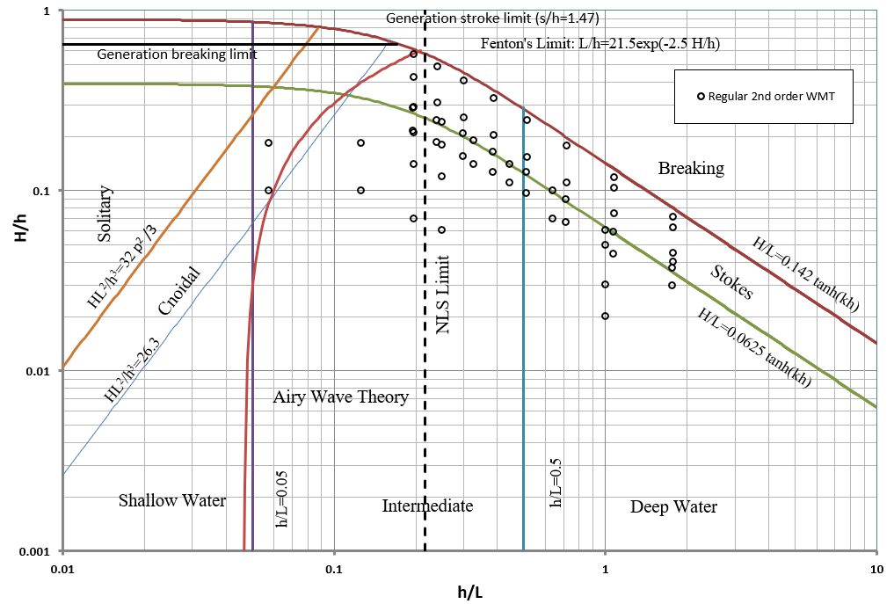

Figure 4: Regular waves generated using 2nd order wavemaker theory (undisturbed condition).

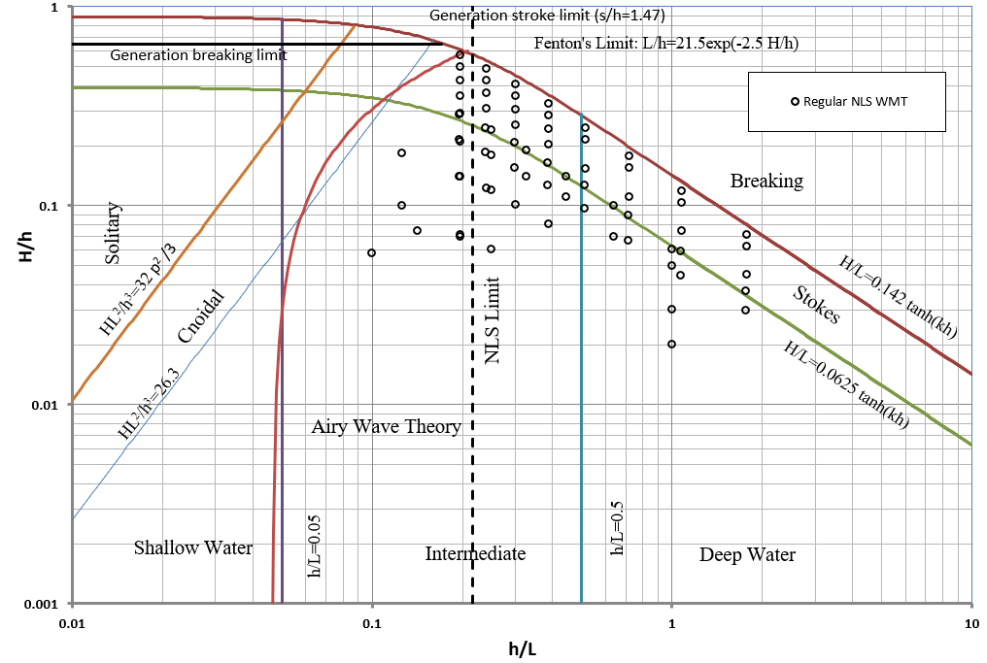

Figure 5: Regular waves generated using NLS wavemaker theory (undisturbed condition).

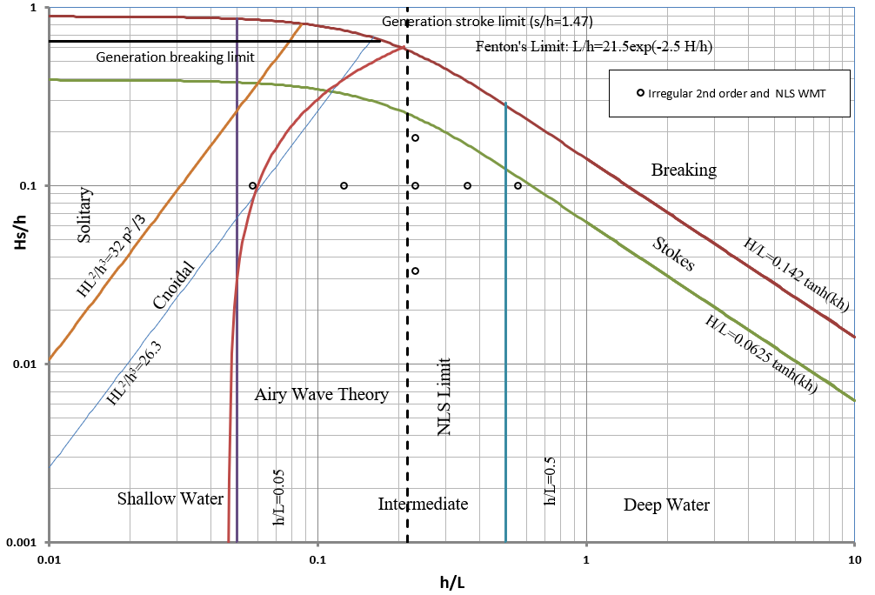

Figure 6: Irregular waves generated using 2nd order and NLS wavemaker theories (undisturbed condition).

# Task M11.2.2: Data set involving WECs within the nonlinear wave field

Effects of nonlinear generation of the wave fields need to be investigated on the responses of a WEC using experimental data. To this end, the same wave generation approach presented in Task M11.2.1 was used with the presence of a WEC in the basin. Wave elevation time series and responses of the WEC components were measured and a dataset was compiled from these measurements.

As during the phase two of undisturbed wave tests described in Task M11.2.1, a total of 14 resistance-based (scwgX and wgX) and 4 ultra-sonic wave gauges (uswgX) were installed, as shown in Figure 2. The coordinates and names of the deployed wave gauges are the same as during the second phase of the undisturbed wave tests and listed in Table 2.

The total number of wave cases for the disturbed conditions (in the presence of the WEC) are 45 regular and 8 irregular waves, as presented in Table 5 and Table 6.

Table 5: Regular wave tests for disturbed condition.

|  |  |  |
| --- | --- | --- |
| Regular waves | | |
| Wavemaker theory | Range of nonlinearity (ak) | Total number of cases |
| Linear wavemaker theory | 0.02-0.35 | 7 |
| 2nd order wavemaker theory | 0.04-0.35 | 20 |
| NLS wavemaker theory | 0.04-0.35 | 18 |
| Total | | 45 |

Table 6: Irregular wave tests for disturbed condition.

|  |  |  |
| --- | --- | --- |
| Irregular waves | | |
| Wavemaker theory | Range of nonlinearity (ak) | Total number of cases |
| 2nd order wavemaker theory | 0.04-0.18 | 4 |
| NLS wavemaker theory | 0.04-0.18 | 4 |
| Total | | 8 |

Further details of the test case wave parameters are presented in Figure 7 - Figure 10, for selected wavemaker theories.

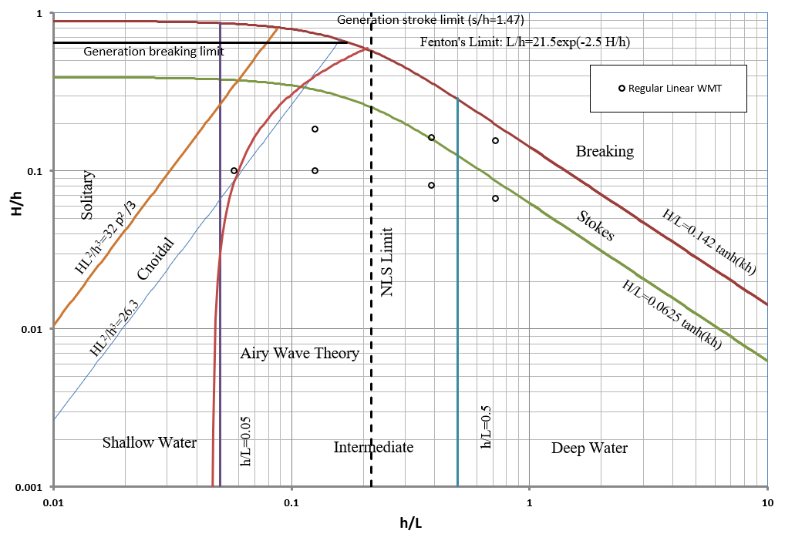

Figure 7: Regular waves generated using linear wavemaker theory (disturbed condition).

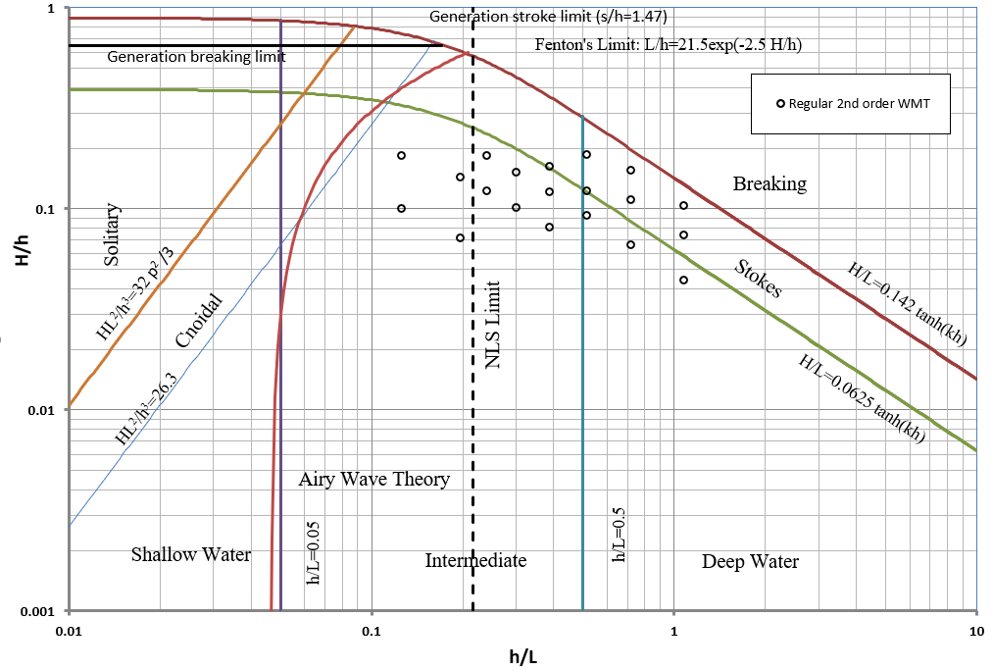

Figure 8: Regular waves generated using 2nd order wavemaker theory (disturbed condition).

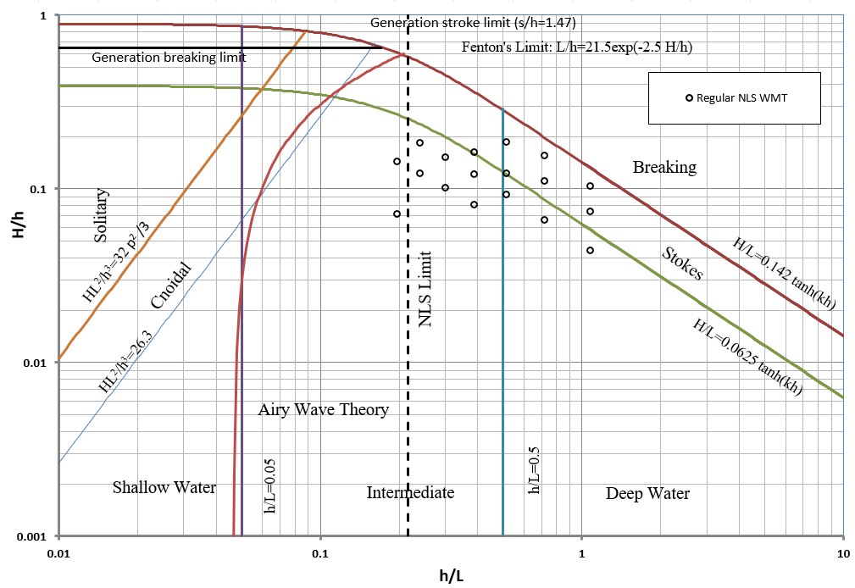

Figure 9: Regular waves generated using NLS wavemaker theory (disturbed condition).

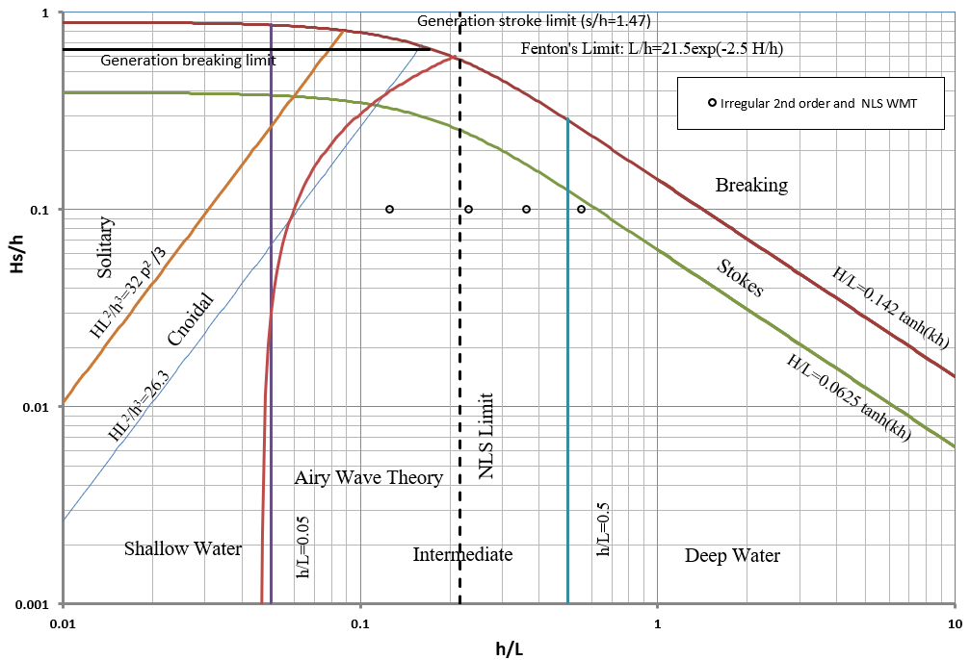

Figure 10: Irregular waves generated using 2nd order and NLS wavemaker theories (disturbed condition).

## Description of the Selected WEC

The selected WEC for the experiments in this task is the FOSWEC-2. The Floating Oscillating Surge Wave Energy Converter (FOSWEC-2) is a scaled prototype designed for testing at the O.H. Hinsdale Wave Research Laboratory (HWRL), Oregon State University, by Sandia National Laboratories (SNL). The device described in this report is a major redesign of a previous scaled prototype (FOSWEC) last tested in 2016 by SNL (Ruehl et al., 2019). The flaps and parts of the platform were retained while the rest of the device was redesigned and built. Major design changes include the replacement and submersion of the PTO system, with both motor/generator units and power electronics under the water surface, and the change to PVC spars/foam for the buoyancy/ballast of the device. Figure 11 shows a CAD rendering of the new FOSWEC-2 design taken from the test plan document created by SNL for their latest testing. Figure 12 show the FOSWEC-2 in the Directional Wave Basin ready for testing. Finally, Figure 13 shows the electrical connections and elements of the model also taken from the test plan.

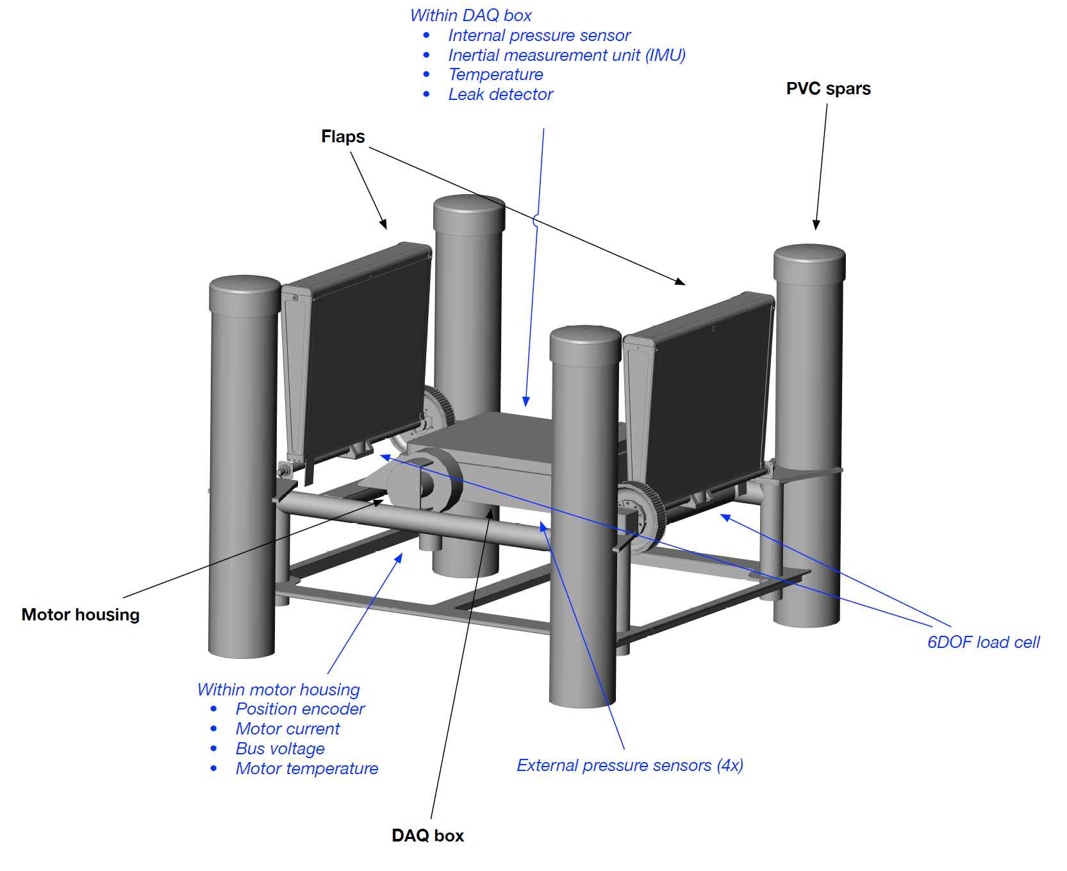

Figure 11: CAD drawing of current FOSWEC-2 model.

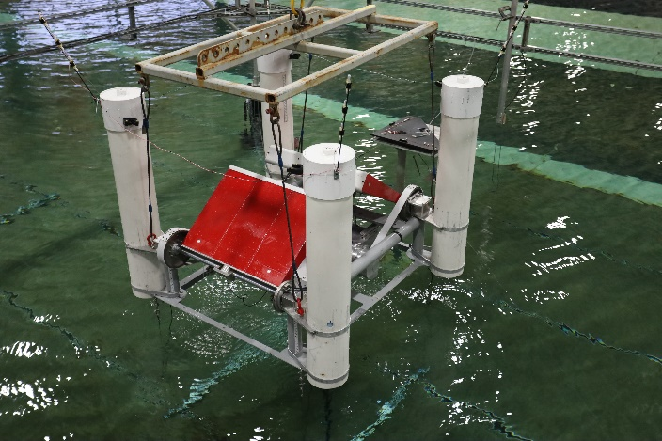 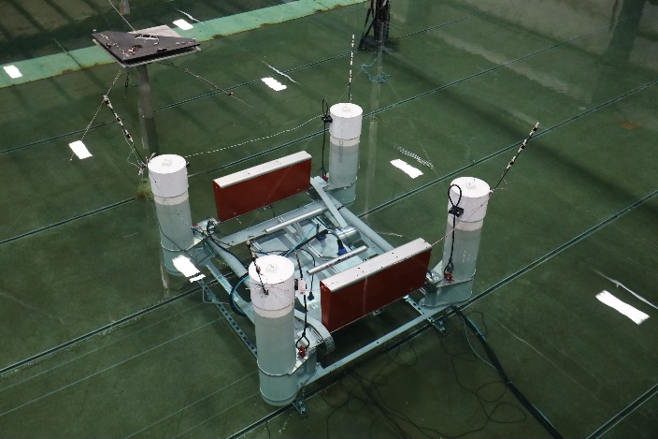

Figure 12: FOSWEC-2 model deployed in the Directional Wave Basin. Left: FOWEC-2 ready to be deployed. Right: FOSWEC-2 ready for testing.

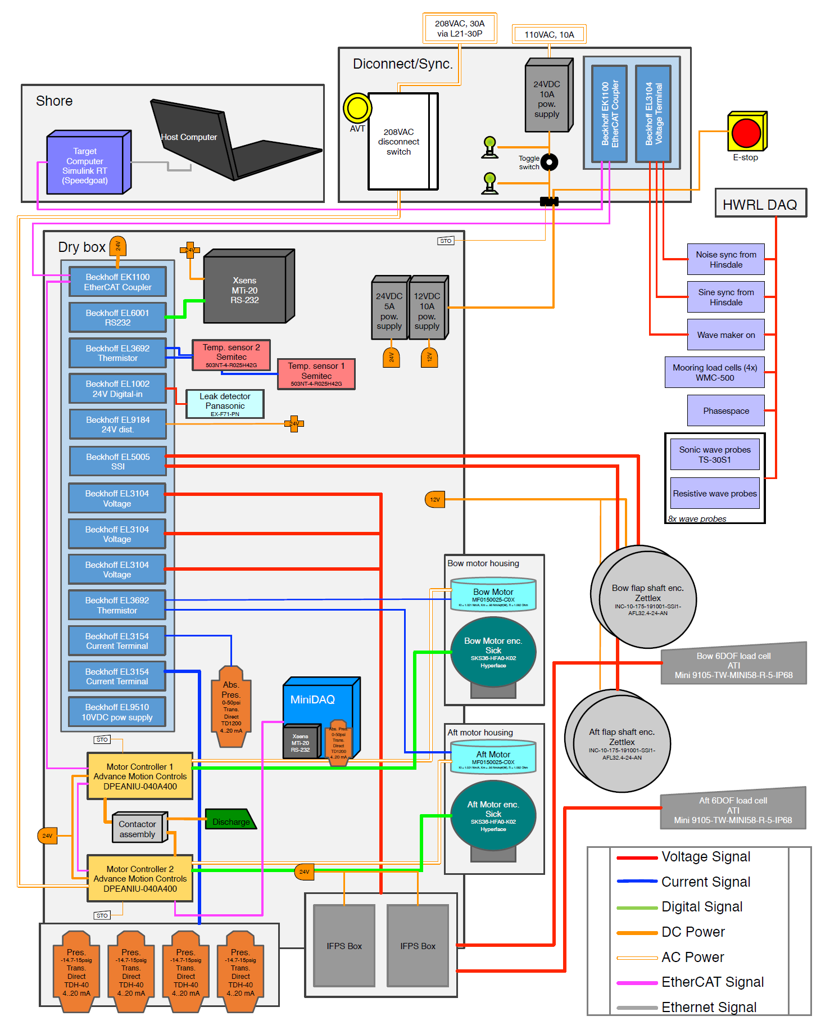

Figure 13: FOSWEC data acquisition system

The Data Acquisition (DAQ) system on the FOSWEC-2 was independent from the HWRL acquisition system, with three synchronization signals logged by both systems. The FOSWEC-2 data was collected on a Speedgoat system using a MATLAB/Simulink environment and EtherCAT communication. Three sampling rates were used for acquisition and control.

What follows is a list of relevant measured parameters which describe the operation of the FOSWEC-2. They have been organized based on how they are recorded in the data set. This data set is in the “foswec” directory and arranged by date of test and time of acquisition directories. Data for each trial is in a data.mat file and requires MATLAB to read. Parenthesis are used to help direct to dataset entries.

* HWRL synchronization signals (bridge)
  + HWRL wavemaker start signal (C_waveStart)
    - Goes high when wavemaker starts, goes low when wavemaker stops
  + Sinewave synchronization signal (C_sine)
    - Used for synchronizing FOSWEC and HWRL recorded data
  + Random duration square wave (C_noise)
    - Used for synchronizing FOSWEC and HWRL recorded data
* Platform specific signals (hull)
  + Four pressure sensors (H_P1…H_P4)
  + Absolute pressure (H_Pabs)
  + Temperature (temp)
* Vertical Reference Unit on platform (imu)
  + Rotations (IMU_thx, IMU_thy,IMU_thz)
  + Angular velocity (IMU_wx,IMU_wy, IMU_wz)
  + Accelerations (IMU_accx, IMU_accy, IMU_accz)
* PTO related signals (bow, aft)
  + Motor measured current (I_m)
  + Motor commanded current (I_ref)
  + DC bus voltage (V_DC)
  + Motor measured speed (w_m)
  + Motor measured angle (th_m)
  + Flap measured angle (ssi_f)
  + Flap 6-DOF load cell (ATI_Fx, ATI_Fy, ATI_Fz, ATI_Tx, ATI_Ty, ATI_Tz)

The FOSWEC-2 was designed so the top of the flaps were 2 cm below the SWL, and the selected mooring system considered 4 tension cables to limit heave and restrain surge and sway, while the flaps depicted the largest oscillatory motions relative to the main platform, leading to a TLP-like mooring layout. Tension forces were measured on each of the cables by means of 4 miniature submersible load cells.

6DOF motions (3 linear, i.e. heave, surge, sway, and 3 angular, i.e. yaw, pitch, roll) were captured with the PhaseSpace system by means of 8 stereoscopic cameras mounted on the 6 m by 6 m frame supporting the wave gauges. To measure the motion of the device, PhaseSpace required 4 carbon fiber poles mounted on each corner of the FOSWEC-2, equipped with 3 LEDs blinking with a characteristic signature. The system is able to transform the detected motions non-intrusively with a framerate of 500 samples per second and transform the LED tracking into rigid body 6DOF motions.

Measurement of wave gauges and mooring load cells were done with the HWRL DAQ. 6DOF motion tracking was performed in the PhaseSpace server and synchronized with the HWRL DAQ.

The FOSWEC-2 was installed at the center of the 6 m by 6 m frame shown in Figure 2. The coordinates of the 4 load cells and the center of the FOSWEC-2 are listed in Table 7.

Table 7. Coordinates of the load cells and the center of the FOSWEC-2

|  |  |  |  |
| --- | --- | --- | --- |
| Load cells | | | |
| Name | x | y | z |
| mooring1 | 14.330 | -2.763 | 0.079 |
| mooring2 | 14.351 | 2.760 | 0.074 |
| mooring3 | 20.437 | -2.771 | 0.077 |
| mooring4 | 20.448 | 2.713 | 0.078 |
| Center of the FOSWEC-2 | | | |
|  | 17.392 | -0.015 | - |

# Task M11.3.5: Nonlinear wave time series software validated using lab data (without WECs)

This section of the report is presented in two parts, first, is the application and validation of a recently proposed nonlinear Schrödinger equation (NLS)-based wavemaker theory and second, a high fidelity NLS numerical model is applied to the experimental data, propagating and predicting the wave elevation time series between measuring points (gauges).

## NLS-based wavemaker theory

A newly developed NLS-based wavemaker theory is implemented to generate nonlinear waves in the experimental facility. This theory is compared to the traditionally used linear and second order wavemaker theories and some results are presented in this report.

The NLS equation is an equation with cubic nonlinearity, explaining the water waves behavior in intermediate to deep water condition with $kh≥1.36$, where *k=2π/L* is the wavenumber, *L* is the wavelength and *h* is the water depth. The maximum range of validity of the NLS equation is determined to be about $ak=0.15$, although larger $ak$ values have been examined during the presented experiment. The details of the proposed wavemaker theory can be found in previously submitted reports and therefore, are not presented here.

Some of the resulting wave field comparisons, using linear, second order, and NLS wavemaker theories are presented in Figure 14 and Figure 15, for the significant wave heights as a function of distance from the wavemaker, for the selected wavemaker theories. The results are from the undisturbed experiment during phase 1 with local water depth of 1.0 m. From these figures, it can be observed that with increasing nonlinearity for each wave period, noticeable differences arise between the linear and 2nd order wavemaker theories, and with the NLS-based wavemaker theory. Also, the evanescence region for NLS-based wavemaker theory is significantly shorter than the other theories and the target wave conditions are achieved much faster. Moreover, all three wavemaker theories provide similar results for the smallest degree of nonlinearity, which is close to the linear condition.

**(d)**

**(c)**

**(b)**

**(a)**

Figure 14: Significant wave heights of the generated wave field for the case in 1.0 m water depth with $T=1.8 s$ and (a) H=0.071, (b) H=0.143, (c) H=0.214, and (d) H=0.285m. The different wavemaker theories, linear, 2nd order, and NLS based generations are compared. On each figure, dashed line presented the target wave height.

**(d)**

**(c)**

**(b)**

**(a)**

Figure 15: Significant wave heights of the generated wave field for the case in 1.0 m water depth with $T=1.6 s$ and (a) H=0.059, (b) H=0.119, (c) H=0.178, and (d) H=0.238 m. The different wavemaker theories, linear, 2nd order, and NLS based generations are compared. On each figure, dashed line presented the target wave height.

## High fidelity NLS equation solver

A high fidelity NLS numerical model, based on split step Fourier method (SSFM), is developed for WEC simulation. This model solves a temporal version of the NLS equation (tNLS) which can be used for analysis of the time series. The dimensionless tNLS equation is in the form:

$$iu_{X}+u_{TT}+2{\left|u\right|}^{2}u=0$$

in which $u$ represents the dimensionless complex envelop function of the wave. The SSFM solves the tNLS equation in two steps; first, the nonlinear term, $iu_{X}=2{\left|u\right|}^{2}u$, and then the linear part, $iu_{X}=u_{TT}$. Details of the SSFM can be found in the literature and will not be covered in detail here.

An example of the results is provided here. This case was particularly chosen from the phase one of the undisturbed experiments, due to its highly nonlinear leading front instability formation, and short duration of the ramping. This type of unstable behavior can be explained by NLS equation. To perform this 2-point prediction, point one (input) is chosen as the measured time series at wg1 (closest WG to the wavemaker) and for point two (target), the furthest wave gauge at the distance of 16 m from wg1 (wg16) is selected. The input time series, along with its envelope, is presented in Figure 16. Two prediction models were executed, linear and tNLS, and results were compared as shown in Figure 17. It can be observed that the tNLS equation can capture the nonlinear leading instability much better than the linear model predictions.



Figure 16: The input time series and envelope function at wg1 (h = 1.0 m, H = 0.1 m, T = 1.0 s).



Figure 17: The predicted and measured time series at wg16 (16 m from wg1), using tNLS and linear models.

## Availability of the data

The recorded data, in engineering units, of all of the different parameters measured during the undisturbed and disturbed wave tests, can be accessed in the DOE MHK Data Repository.

# References

**Experimental Testing of a Floating Oscillating Surge Wave Energy Converter**. Sandia National Laboratories report SAND2019-3087. Ruehl, K., Forbush, D., Lomonaco, P., Bosma, B., Simmons, A., Gunawan, B., Bacelli, G., Michelen Strofer, M. March 2019.

Miche, R*. Mouvements ondulatoirs des mers en profondeur constante on decroissant.* Ann. Ponts Chaussées 1944, 2, 25–78.